

CAPSTONE PROJECT REPORT
Report 1 – Project Introduction

– Hanoi, Jan 2026 –
Table of Contents
I. Record of Changes 3
Modify Major Features 3
II. Definition and Acronyms 4
III. Project Introduction 4
1. Overview 4
1.1 Project Information 4
1.2 Project Purpose 4
1.3 Project Stakeholders 5
2. Product Background 5
3. Existing Solutions 6
3.1 Riki 6
3.2 IIG Viet Nam 7
4. Business Opportunity 8
5. Software Product Vision 9
6. Project Scope & Limitations 10
6.1 Major Features 10
6.2 Limitations & Exclusions 11

I. Record of Changes
Date | A*  M, D | In charge | Change Description
13/01/2026 | A | LinhVTK | Add Definition and Acronyms, Project Introduction
15/01/2026 | M | LinhVTK | Modify Project Name, Product Background, Business Opportunity, Software Product Vision
21/01/2026 | M | LinhVTK | Modify Existing System
24/01/2026 | M | LinhVTK | Modify Project Scope & Limitations
03/02/2026 | M | LinhVTK | Modify Limitations & Exclusions
27/03/2026 | M | LinhVTK | Modify Major Features
*A - Added M - Modified D - Deleted

II. Definition and Acronyms
Acronym | Definition
Nova LMS | Nova Learning Management System

III. Project Introduction

1. Overview

1.1 Project Information
- English name: Nova Learning Management System
- Vietnamese name: Hệ thống quản lý học tập Nova
- Project code: NLMS
- Group name: ISP490_G1
- Software type: Web System

1.2 Project Purpose
The purpose of this project is to develop the Nova Learning Management System (NLMS), a web-based learning management platform designed to support the operation of online English training centers. The system aims to provide an integrated environment for managing courses, learning content, teachers, students, assessments, and learning progress within a single platform.
The Nova LMS is intended to facilitate effective online teaching and learning by centralizing academic management, improving data consistency, and reducing manual administrative workload. In addition, the system integrates artificial intelligence to support automated assignment evaluation, learning progress analysis, and personalized feedback, while providing structured learning paths, flexible class management, and continuous monitoring of learning outcomes in order to enhance teaching quality and learner experience.
This document serves as a guideline for defining the objectives, scope, and intended functionalities of the Nova LMS, as well as providing a foundation for the design, development, and evaluation of the proposed solution.

1.3 Project Stakeholders
Full Name | Role | Email | Mobile
Nguyen Trung Kien | Lecturer | kiennt@fe.edu.vn
Mai Ngoc Dat | Leader | datmnhe171114@fpt.edu.vn | 0702899813
Vu Thi Kieu Linh | Member | linhvtkhe170509@fpt.edu.vn | 0962653191
Mai Chi Thanh | Member | thanhmche172833@fpt.edu.vn | 0989878056
Nguyen Chu Tu | Member | tunche170493@fpt.edu.vn | 0968716203
Dinh Ha Duc Anh | Member | anhdhdhe173374@fpt.edu.vn | 0332197541

2. Product Background
In the rapidly evolving education market, many English language training centers face challenges in managing and delivering online learning effectively. The lack of an integrated learning management platform leads to fragmented teaching processes, inconsistent academic data, and limited ability to monitor learners’ progress, which reduces operational efficiency and affects teaching quality.
Moreover, the academic and administrative staff in many centers still rely on manual and disconnected tools such as spreadsheets, cloud storage, video conferencing platforms, and messaging applications. This limits automation, increases administrative workload, prolongs academic operations, and restricts the ability to manage learning activities and make timely instructional decisions.
Meanwhile, online education and digital learning platforms are becoming an inevitable global trend, helping institutions improve teaching efficiency, personalize learning experiences, and expand training services. However, many existing solutions focus mainly on content delivery or exam preparation and do not provide a comprehensive system that integrates learning management with academic administration in a unified platform.
In response to this demand, the Nova LMS is proposed as an integrated web-based platform that supports the entire online learning and academic management process from course organization and content delivery to class management, assessment, and learning progress tracking. The system aims to improve operational efficiency, ensure consistent teaching quality, and provide a scalable foundation for modern online English training centers.

3. Existing Solutions

3.1 Riki
3.1.1 Description
Riki Nihongo is a reputable Japanese language training center in Vietnam that offers comprehensive online and offline courses for learners of Japanese at different proficiency levels, including JLPT test preparation. While Riki is not focused on English language education, it represents a real example of how language centers are using online platforms to support foreign language learning.
3.1.2 Website: https://riki.edu.vn
3.1.3 Actors
Students, instructors, administrative staff.
3.1.4 Key Features
- Digital learning materials accessible for self-study.
- Course enrollment and student support via the center’s online portals.
- Online Japanese courses through recorded lessons and scheduled live sessions.
3.1.5 Advantages
- Availability of online learning options for learners with diverse schedules.
- Structured foreign language programs tailored for different proficiency levels.
3.1.6 Limitations
- Academic, administrative, and learning progress functions are not centralized.
- There is limited systematic tracking of learner performance within a unified platform.
- The center’s digital tools focus on content delivery rather than integrated management.

3.2 IIG Viet Nam
3.2.1 Description
IIG Vietnam is a leading organization in Vietnam and the region for administering international standardized tests in English and other fields. It is the official representative of major international testing bodies such as ETS and offers testing services as well as consulting and training solutions.
3.2.2 Website: https://iigvietnam.com
3.2.3 Actors
Test candidates, instructors, academic coordinators, administrators.
3.2.4 Key Features
- Support for online registration and candidate information management for exams.
- Consulting services and training solutions for institutions, businesses, and individuals.
- Administration of international English tests such as TOEIC, TOEFL, and related assessments.
Advantages
- Strong reputation and authority in standardized English testing and certification.
- Comprehensive support services including preparation courses, online learning tools, and teacher training.
Limitations
- Academic and administrative coordination often requires multiple disconnected tools.
- IIG’s digital offerings are primarily focused on testing and preparation rather than a full learning management system.
- Core LMS functions such as centralized course delivery, unified progress tracking, and teacher/student management are not fully provided in a single integrated platform.

4. Business Opportunity
The online education market in Vietnam and worldwide is growing rapidly, especially in the field of foreign language training. However, many English training centers and online learning providers still face major challenges in managing learning activities and academic operations effectively. In practice, a large amount of administrative effort is wasted due to the lack of integrated learning management tools, while teaching staff often lack sufficient digital support to organize courses, monitor learning progress, and evaluate learning outcomes in a scientific and efficient manner.
On the other hand, existing learning platforms on the market mainly focus on content delivery or exam preparation, but do not yet provide the capability for end-to-end learning management from course organization, class scheduling, and learning content delivery to automated assessment, progress analysis, and academic administration. This creates a significant gap for an integrated LMS solution that combines learning management with intelligent academic support.
The emergence of the Nova LMS presents a clear opportunity to address these issues:
- Helps training centers manage learning activities more efficiently and reduce administrative workload.
- Supports teachers and students with structured learning paths, centralized materials, and transparent progress tracking.
- Applies artificial intelligence to automate assignment evaluation, analyze learning progress, and provide timely feedback.
- Opens up opportunities for training institutions to improve service quality and expand their online education operations in a scalable manner.
Compared to traditional learning tools or fragmented management systems, Nova LMS differentiates itself by integrating multiple functions into a single platform: managing courses and classes, delivering learning content, automating assessments with AI, and providing intelligent learning analytics through a centralized dashboard. These are the core values that many training centers currently struggle to achieve when relying only on standalone tools or manual processes.
With the global trend toward digital education and intelligent learning systems, the project not only helps training centers improve operational efficiency and teaching quality, but also contributes to promoting digital transformation and sustainable development in modern education.

5. Software Product Vision
For English training centers seeking to improve online teaching effectiveness and academic management, the Nova LMS is an integrated web-based platform that supports learning activities and academic operations within a unified system. The system enables training centers to organize courses and classes, manage teachers and students, deliver learning content, conduct assessments, and track learning progress in a centralized environment.
The platform leverages artificial intelligence to support automated assignment evaluation, learning progress analysis, and personalized feedback. Teachers can efficiently manage teaching content, assignments, and assessments, while AI assists in evaluating student submissions, identifying learning gaps, and providing data-driven insights to improve teaching strategies. Students can access structured learning paths, receive timely feedback, and monitor their learning performance in a transparent and consistent manner.
Unlike traditional learning solutions that separate content delivery, class management, and academic administration, Nova LMS provides a unified ecosystem where teaching activities and learning outcomes are continuously improved through centralized data management and intelligent analytics. With key features such as flexible class scheduling, structured learning paths, automated assessment, progress tracking, and performance dashboards, the system fosters an effective and modern online learning environment.
By aligning with modern online education trends and long-term digital transformation strategies, and by integrating artificial intelligence for automated assignment assessment, learning analytics, and personalized feedback, Nova LMS aims to become a reliable and scalable digital platform for English training centers in the era of modern education.

6. Project Scope & Limitations

6.1 Major Features
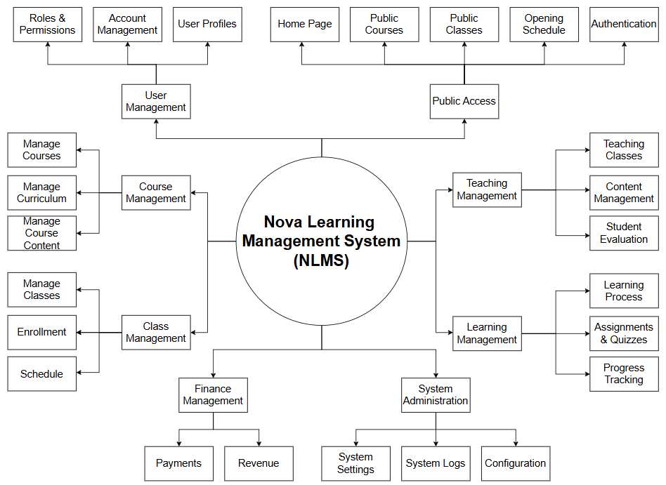
Figure 1: Feature Tree of Nova LMS
Link: Feature Tree of Nova LMS

# | Feature ID | Feature Name | Description
1 | FE-01 | Public Access | Enable guest users to access public features including homepage viewing, course browsing, public class listing, placement test, and authentication
2 | FE-02 | User Management | Manage user accounts, profiles, roles and permissions within the system
3 | FE-03 | Course Management | Create, update and manage courses, curriculum and learning content
4 | FE-04 | Class Management | Manage classes, student enrollment and class schedules
5 | FE-05 | Learning Management | Support learning activities including lessons, assignments, quizzes and progress tracking
6 | FE-06 | Teaching Management | Enable instructors to manage teaching content, classes and evaluate students
7 | FE-07 | Finance Management | Handle course payments and revenue tracking
8 | FE-08 | System Administration | Configure system settings, manage logs and maintain system operations

6.2 Limitations & Exclusions
# | Limitation ID | Limitations | Description
1 | LI-1 | No Public Course Marketplace | The system is designed only for a single English training center and does not provide a public marketplace for multiple institutions.
2 | LI-2 | No Built-in Video Conferencing | The system does not provide its own video conferencing service and relies on external platforms such as Google Meet.

